Activity No 1.
Title of the Event | Marketing Club Event “ Think Beyond Tradition: Quiz on Ambush and Guerrilla Marketing” | 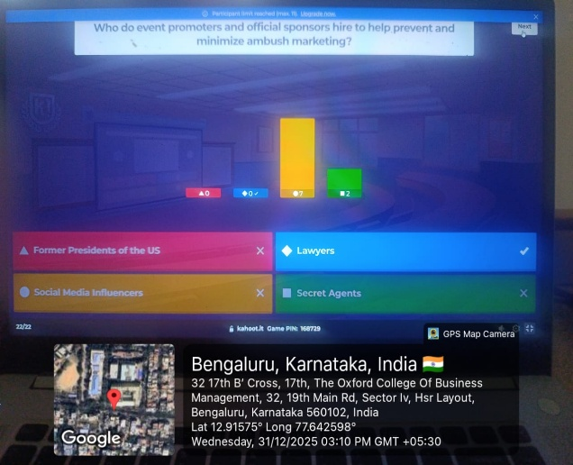
Day and Date | 31 December 2025
Venue (With all details ) | Room No-309
In collaboration with ( if any)
Details of Resource Person With Designation | Dr.Veto Dey | 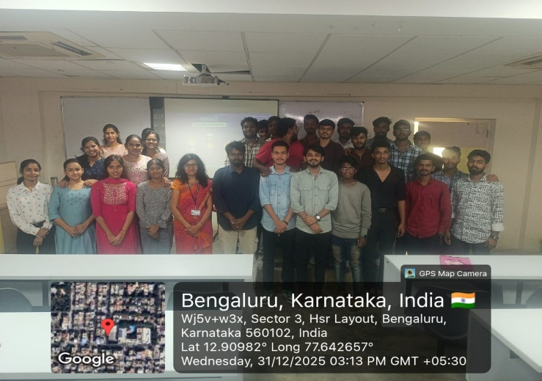
Organizing Department/Coordinators | Business Management, Dr.Veto Dey
Course and semester | MBA I Sem
No of Students & Faculty Participants | 30

Coordinator HoD Vice-Principal Principal

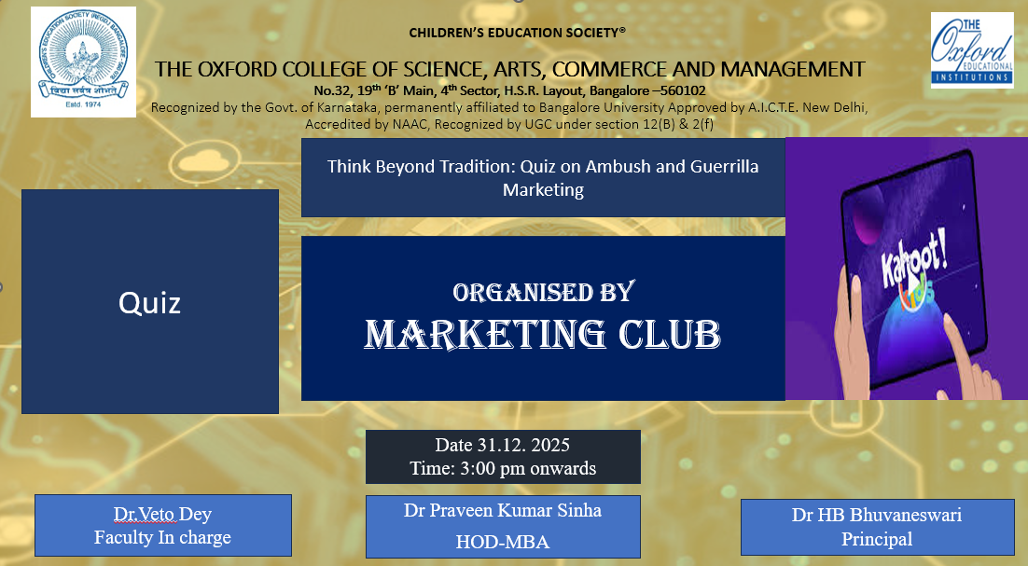
Introduction
In today’s dynamic business environment, marketers increasingly rely on unconventional strategies to capture consumer attention and create brand recall. To familiarize students with such contemporary practices, the Department of MBA organized an interactive learning activity during the Marketing Club hour. The objective of the session was to enhance conceptual understanding of Ambush Marketing and Guerrilla Marketing through a technology-enabled and student-centric approach.
Description of the Activity
The activity was conducted on 31 December 2025 for MBA Semester I students in the form of a Kahoot-based quiz. The quiz consisted of multiple-choice questions covering key concepts, characteristics, ethical issues, and real-world examples of ambush and guerrilla marketing. Students participated actively using their mobile devices, responding to questions in real time. Instant feedback, scoreboards, and discussion after each question helped reinforce learning and maintain high levels of engagement. The competitive and interactive format encouraged students to think critically and apply theoretical knowledge to practical marketing scenarios.
Outcome of the Activity
The activity significantly improved students’ understanding of unconventional marketing strategies. Students were able to clearly differentiate between ambush marketing and guerrilla marketing and identify their application in live market situations. The quiz enhanced analytical thinking, quick decision-making, and digital learning skills. Active participation and enthusiasm observed during the session reflected improved student involvement and interest in marketing concepts beyond traditional classroom teaching.
Conclusion
The Kahoot-based quiz proved to be an effective pedagogical tool for promoting experiential and interactive learning. It successfully met its learning objectives by combining technology with conceptual clarity and student engagement. Such innovative activities contribute to holistic learning and better retention of marketing concepts. The Department of MBA will continue to organize similar interactive sessions to bridge the gap between theory and practice and to enrich the overall learning experience of students.

